

DEPARTMENT OF COMPUTER SCIENCE
WITH ARTIFICIAL INTELLIGENCE

IBM PROJECT
BUSINESS INTELLIGENCE-BASED HOSPITAL MANAGEMENT REPORTING SYSTEM FOR COVID-19 ANALYSIS
Submitted by
YASHIKA.J (222511551)
ROHINI.M(222511546)
BAKIYALAKSHMI.V(222511538)

BACHELOR OF SCIENCE IN COMPUTER
SCIENCE WITH ARTIFICIAL INTELLIGENCE

Under the guidance of
Mr.Kavin Chakaravarthi.V M- Corporate Trainer

2025 - 2026

DECLARATION

We, YASHIKA.J,ROHINI.M,BAKIYALAKSHMI.V, hereby declare that this project report on “Business Inteligence-Based Hospital Management Reporting system for COVID-19 Analysis”submitted to the University of Madras in partial fulfillment of the requirement for the award of the Degree Bachelor of Computer Science with Artificial Intelligence under the guidance MRS CAROLIN JOSHIBA.S , HEAD OF DEPARTMENT and Mr.KAVIN CHAKARAVARTHI.V M has not been submitted earlier to any other university or institute for the award of any degree.

YASHIKA.J
ROHINI.M
BAKIYALAKSHMI.V

Place:PADUR
Date: 03/02/2026

BONAFIDE CERTIFICATE
This is to certify that the project titled “Business Intelligence-based Hospital Management Reporting system for COVID-19 Analysis” is the bonafide work done by, YASHIKA.J,ROHINI.M,BAKIYALAKSHMI.V hereby and first-year student of Jeppiaar College of Arts and Science, Padur, Chennai in partial fulfillment of the requirement for the award of the Degree of Bachelor of Computer Science with Artificial Intelligence 2025-2026.

PROJECT GUIDE: HEAD OF THE DEPARTMENT:

Mr.KAVIN CHAKARAVARTHI.V M MRS.CAROLIN JOSHIBA S
Date: 03/02/2026

S. No | INDEX | Page No
 | Introduction
 | Abstraction

Overview
Data Collection
Data Processing
Data Visualization
Predictive Analysis
Problem Statement
- Inefficient Monitoring
- Resource Shortages
- Delayed Reporting
- Limited Predictive Capability
 | Objectives

Methodology
- Data Collection
- Data Cleaning & Preprocessing
- Data Integration
- BI Tool Implementation
 | Visualization
 | Conclusion
 | Reference

1.Introduction
The COVID-19 pandemic created unprecedented challenges for healthcare systems worldwide. Hospitals faced sudden surges of patients, shortages of critical resources such as ICU beds, ventilators, and protective equipment, and an urgent need for timely data-driven decision-making. Managing large volumes of patient data manually led to delays and errors, which could have serious consequences.
Business Intelligence (BI) provides tools and technologies to collect, process, and visualize data efficiently. BI enables hospitals to gain insights from data in real-time, monitor trends, and optimize resource allocation. The aim of this project is to design a BI-based hospital management reporting system that helps healthcare administrators analyze COVID-19 data, predict resource requirements, and improve overall hospital operations.
The system collects data from multiple departments, including patient records, laboratory results, and hospital inventories. It then processes this data and presents it through interactive dashboards, providing decision-makers with actionable insights.

2. Abstract
This project focuses on developing a Business Intelligence-based Hospital Management Reporting System for analyzing COVID-19 data. The system integrates multiple sources of hospital data into a centralized platform and offers comprehensive reporting and visualization features.
Key functionalities include:
- Tracking patient admission and discharge trends.
- Monitoring ICU bed and ventilator utilization.
- Analyzing treatment outcomes, such as recovery and mortality rates.
- Forecasting resource needs using historical data.
By leveraging BI tools such as IBM Cognos, Power BI, or Tableau, the system enables hospitals to make informed, data-driven decisions quickly. The solution supports efficient patient management, resource allocation, and strategic planning during pandemic conditions.

3. Overview
The proposed BI-based reporting system is designed as a centralized, user-friendly platform for hospital administrators and medical staff. It consists of four main components:
- Data Collection:
  - Integrates data from hospital management systems, electronic health records (EHR), and lab reports.
  - Ensures accurate and timely updates from different departments.
- Data Processing:
  - Cleans, filters, and organizes raw data.
  - Removes duplicates and corrects errors for reliable analysis.
- Data Visualization:
  - Uses dashboards and interactive charts for a quick understanding of trends.
  - Visualizes patient admissions, ICU occupancy, ventilator availability, and recovery rates.
- Predictive Analysis:
  - Applies statistical and BI models to forecast future trends.
  - Helps administrators plan for resource allocation and emergency preparedness.
The system is scalable and adaptable to include new data sources or hospital departments as required. It promotes real-time reporting and ensures timely decision-making in critical situations.

4. Problem Statement
During the COVID-19 pandemic, hospitals faced several critical challenges:
- Inefficient Monitoring: Manual tracking of patient data slowed decision-making.
- Resource Shortages: Lack of real-time information caused delays in allocating ICU beds, ventilators, and PPE.
- Delayed Reporting: Administrators could not access timely reports to respond effectively to patient surges.
- Limited Predictive Capability: Without historical and real-time data analysis, hospitals struggled to forecast patient inflow and prepare accordingly.
Proposed Solution: A BI-based reporting system that provides real-time dashboards, predictive insights, and data-driven resource management, helping hospitals manage COVID-19 more effectively.

5. Objectives
The main objectives of this project are:
- To design a real-time hospital management reporting system for COVID-19.
- To analyze patient data to identify trends in admissions, discharges, and treatment outcomes.
- To optimize hospital resources, including ICU beds, ventilators, and staff.
- To provide predictive insights for efficient planning and preparedness.
- To improve decision-making processes through data-driven dashboards and reports.

6. Methodology
The methodology follows these structured steps:
Step 1: Data Collection
- Gather data from patient records, laboratory reports, hospital inventories, and staffing schedules.
- Include COVID-19-specific parameters like symptoms, test results, oxygen levels, and comorbidities.

Step 2: Data Cleaning & Preprocessing
- Remove duplicate entries and handle missing data.
- Standardize formats to ensure consistency.
Step 3: Data Integration
- Combine datasets from multiple hospital departments into a centralized database.
- Ensure data integrity and security using encryption and access controls.
Step 4: BI Tool Implementation
- Use IBM Cognos Analytics or Power BI to create dashboards and reports.
- Configure drill-down options for detailed analysis of specific departments or metrics.
Step 5: Data Analysis & Visualization
- Develop interactive dashboards for patient admissions, resource utilization, recovery rates, and mortality rates.
- Use charts, graphs, and heatmaps for intuitive understanding of data.
Step 6: Predictive Modeling
- Apply forecasting models to predict patient inflow, ICU occupancy, and resource shortages.
- Provide administrators with actionable insights for planning and emergency response.

7. Visualization
The system offers a range of visualizations for effective hospital management:
- Patient Admission Trends: Line charts showing daily and weekly COVID-19 admissions.
- Resource Utilization: Bar charts for ICU beds, ventilators, and PPE stock levels.
- Recovery & Mortality Rates: Pie charts showing outcomes by age, gender, or comorbidities.
- Geographical Analysis: Heat maps showing COVID-19 case distribution in different regions.
- Predictive Insights: Dashboards forecasting hospital capacity and resource needs.
These visualizations support informed decisions, ensuring hospitals are prepared for patient surges and resource allocation challenges.
8.Screenshot
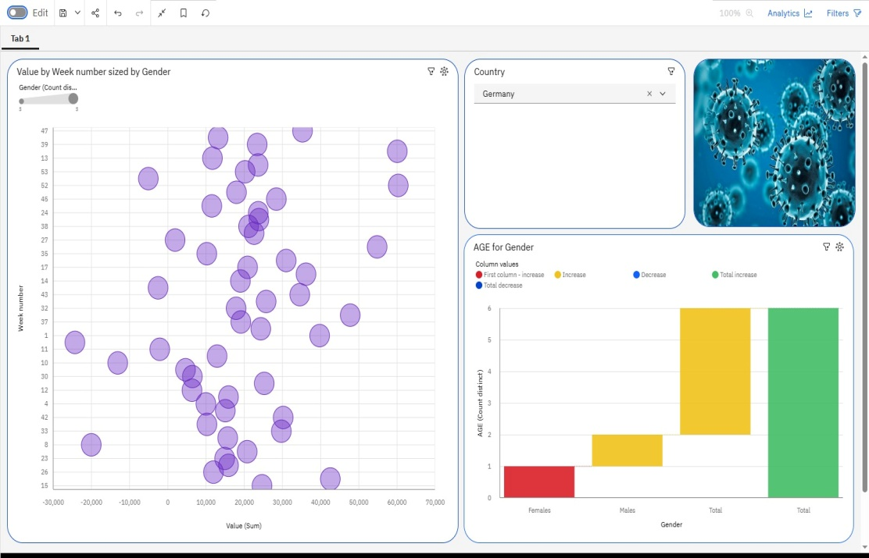

9. Conclusion
The Business Intelligence-Based Hospital Management Reporting System provides hospitals with an effective way to manage COVID-19 data. Real-time dashboards and predictive analytics help improve patient care, optimize resource allocation, and support timely decision-making. By leveraging BI tools, hospitals can respond quickly to crises, reduce errors, and ensure better outcomes for patients.
This project highlights the critical role of data-driven approaches in healthcare management and demonstrates how technology can help tackle challenges posed by pandemics.

10.Reference

- Click here to access dataset

- Click here for access Git

